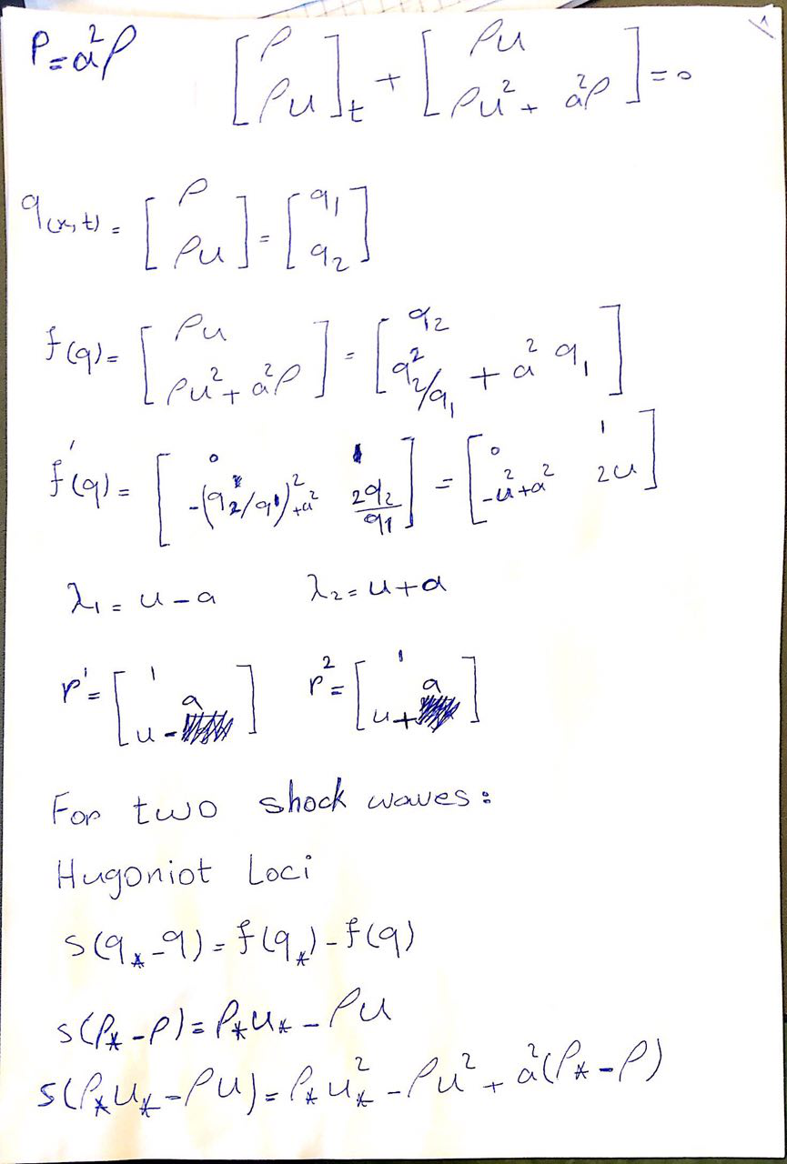

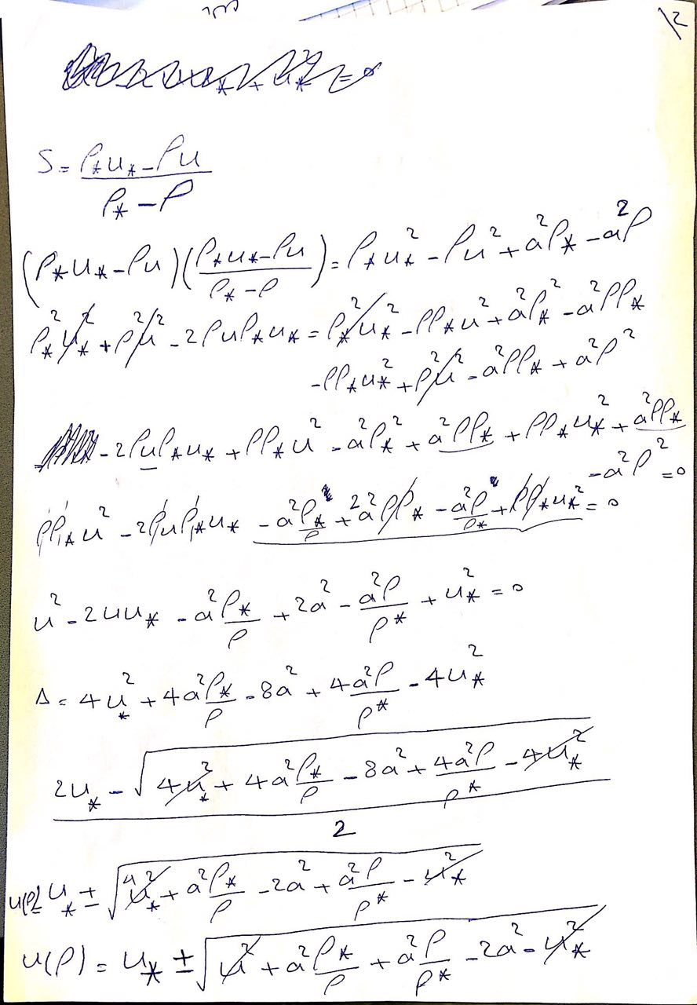

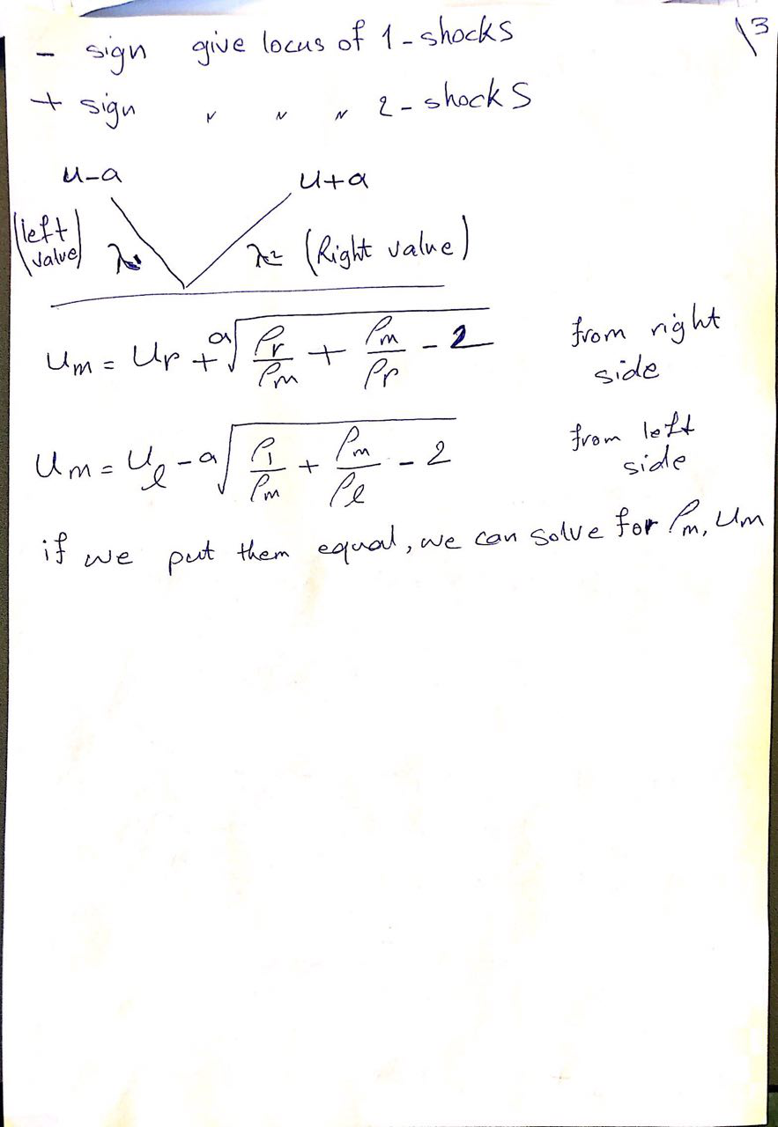

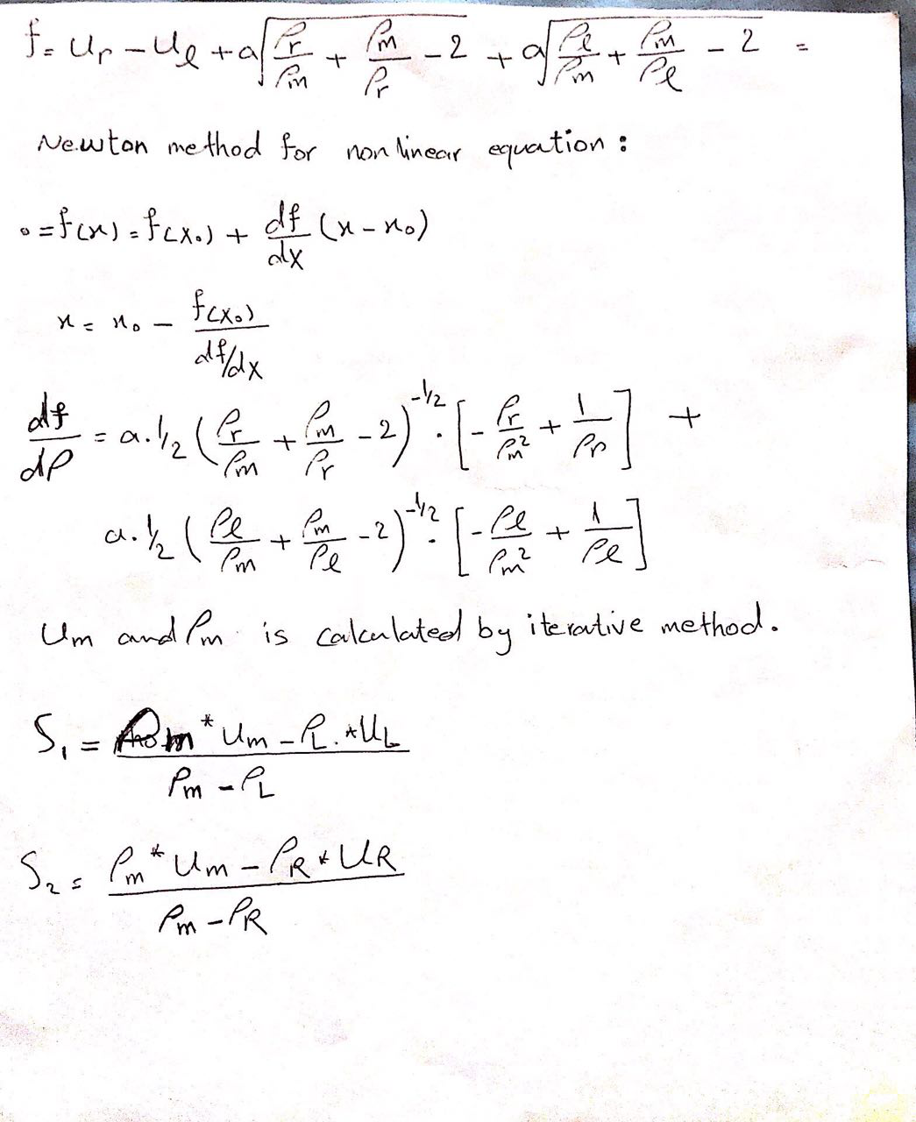  
The equation of left wave and right wave for finding the medium velocity and density have been solved by newton methods. Also, the computer simulation for all shock wave is as below.

The computer simulation for two shock wave is as below :

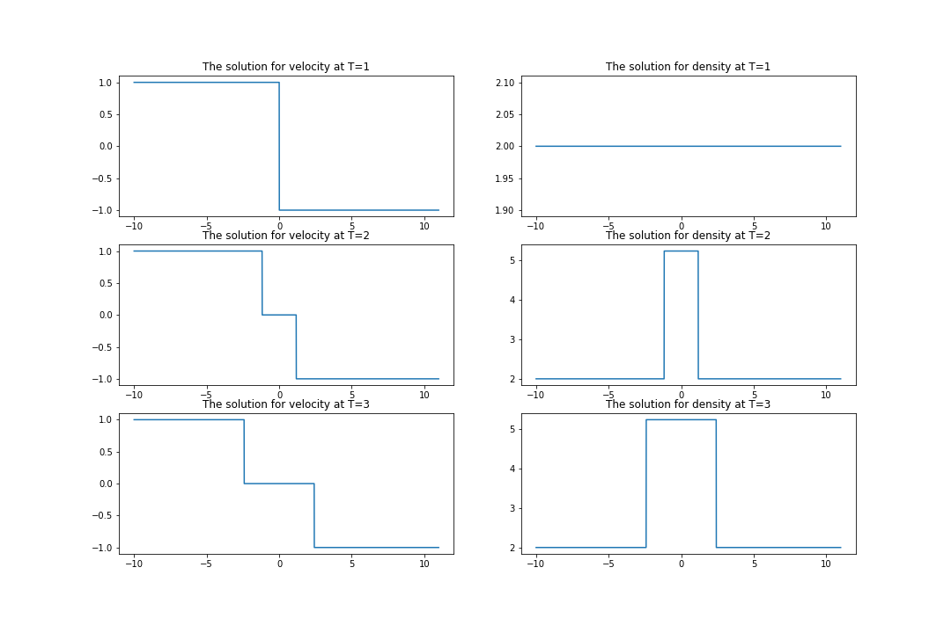

This figure is corresponded for UL = 1 and UR = -1 , left density = 2 , right density = 2 , a =1 , delta T = 0.1 and Delta X = 0.01